Cognitive Interjections

🔹 What Are Cognitive Interjections?
# Source: AI Source: Provided by: [Data Path: Persons Table -> ID Column: 1, Name_En Column: Motasem Essam] -> From: [Chatgpt (GPT-4-turbo)] on [7/28/2025]
Cognitive interjections are words or short expressions that show a person’s mental reaction, such as:
- Realization
- Thought
- Doubt
- Understanding
- Confusion
They reflect what someone is thinking or how they process information in real time.

✅ Key Features
# Source: AI Source: Provided by: [Data Path: Persons Table -> ID Column: 1, Name_En Column: Motasem Essam] -> From: [Chatgpt (GPT-4-turbo)] on [7/28/2025]
- Express mental or intellectual responses
- Often used in conversations, dialogues, or when thinking aloud
- Common in spoken language and informal writing

🧩 Common Cognitive Interjections
# Source: AI Source: Provided by: [Data Path: Persons Table -> ID Column: 1, Name_En Column: Motasem Essam] -> From: [Chatgpt (GPT-4-turbo)] on [7/28/2025]
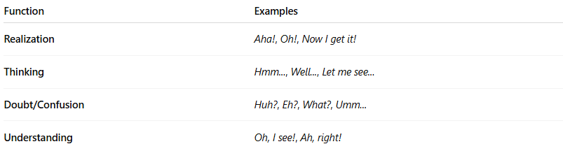
Function | Examples
Realization | Aha!, Oh!, Now I get it!
Thinking | Hmm..., Well..., Let me see...
Doubt/Confusion | Huh?, Eh?, What?, Umm...
Understanding | Oh, I see!, Ah, right!

📚 Example Sentences
# Source: AI Source: Provided by: [Data Path: Persons Table -> ID Column: 1, Name_En Column: Motasem Essam] -> From: [Chatgpt (GPT-4-turbo)] on [7/28/2025]
- Aha! That’s the missing piece! (realization)
- Hmm... I’m not sure what to do. (thinking)
- Huh? What did you say? (confusion)
- Oh, I see! That makes sense now. (understanding)
- Well... I guess we could try again. (hesitation)

